## **FPGAs vs. CPU, GPU, and ASIC**

**The following diagram and table show how FPGAs compare to other processors.**

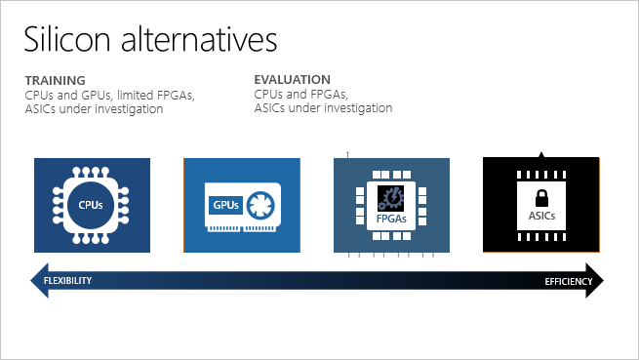

TABLE 1

|  |  |  |
| --- | --- | --- |
| **Processor** |  | **Description** |
| Application-specific integrated circuits | ASICs | Custom circuits, such as Google's TensorFlow Processor Units (TPU), provide the highest efficiency. They can't be reconfigured as your needs change. |
| Field-programmable gate arrays | FPGAs | FPGAs, such as those available on Azure, provide performance close to ASICs. They are also flexible and reconfigurable over time, to implement new logic. |
| Graphics processing units | GPUs | A popular choice for AI computations. GPUs offer parallel processing capabilities, making it faster at image rendering than CPUs. |
| Central processing units | CPUs | General-purpose processors, the performance of which isn't ideal for graphics and video processing. |